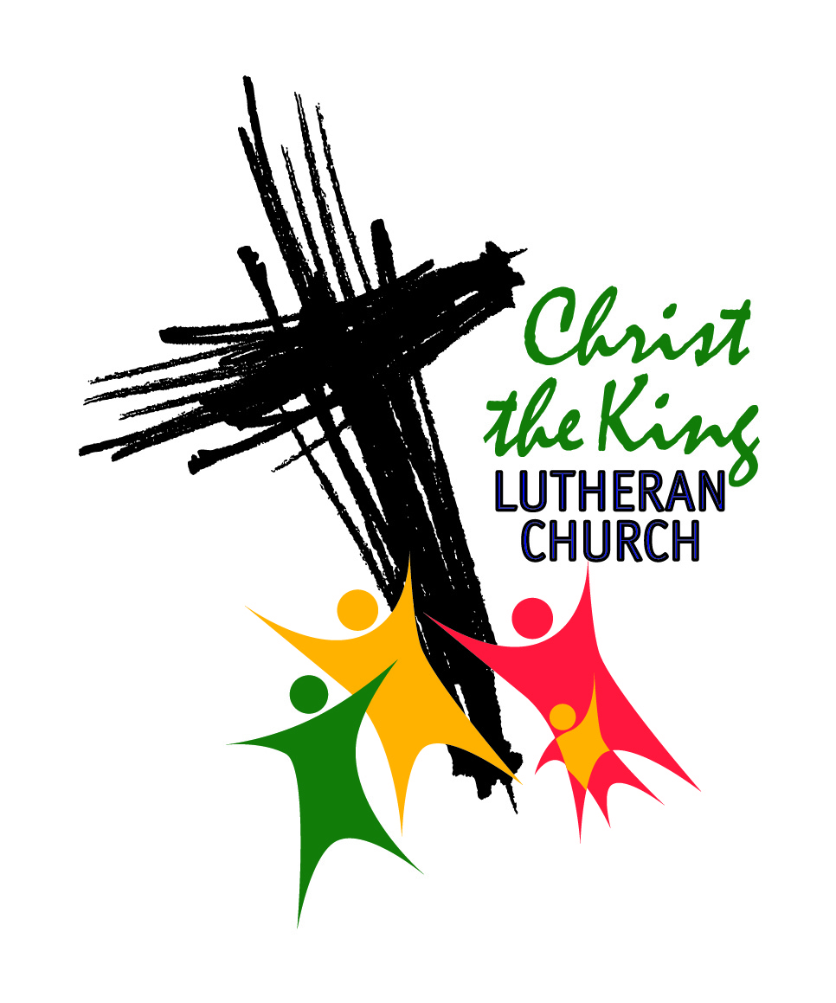
JOB DESCRIPTION

Position: Coordinator of Youth Ministry Revised: March, 2014

Reports To: Pastor & Cong Council Status: Part-time/Professional/Exempt
Purpose: Under the direction of the Pastor and the Chair of the Education Committee, shares the good news of Jesus Christ and brings people to know Christ by coordinating activities for junior high and high school youth of this church. Coordinates volunteer committees involved in these activities.
Essential Job Functions:
- Coordinates and supervises activities for junior high and high school youth to include a planned Youtheran fellowship and Bible study weekly during the school year and monthly during the summer.
- Assists church leaders in the development and implementation of programs and activities for youth.
- Plans and carries out one social event per year that includes both youth and confirmation-aged children.
- Works with the Education Committee to plan and carry out weekly Christian education activities for youth, as well as assisting the committee in the planning and execution of annual Vacation Bible School and other special events such as Rally Day, Christmas Programs and youth services.
- May teach a Sunday class as determined by the Pastor and Education Committee.
- Attends and acts as chaperon of youth at Church Council approved overnight events such as the ELCA youth gathering.
- Ensures all youth activities are carried out within budget guidelines set by the congregation council.
- Ensures written parent/guardian permission is obtained for any youth activities taking place away from the church grounds or for any overnight activities. Maintains records of same.
- Ensures that all adult participants (18 and over) in youth activities meet the Congregation Council’s requirements for working with children, including but not limited to passing a criminal background screen.
- Communicates with parents to ensure all are aware of youth activities and to gain support and input on same. Publishes a youth calendar.
- When youth activities involve church volunteers and/or committees ensures communication with all affected parties and approval of appropriate committee chairs.
- Submits monthly update to the Congregation Council on Youth activities and plans.
- Maintains records of youth activities including scope, cost, post-activity evaluation and suggestions for improvement.
- Promotes youth attendance by regularly attending worship services and other Church activities.
- Exemplifies the servant life and seeks to motivate others to live it by adhering to the standards set forth in the Vision and Expectations Associates in Ministry, Deaconesses and Diaconal Ministers in the Evangelical Lutheran Church in America.
- Attends and participates in staff meetings.
- Attends synod and/or area youth leader meetings.
- Performs others duties as assigned by the Pastor and/or Congregation Council.
Required Knowledge Skills and Abilities:
- High School diploma and one year of related experience or the equivalent combination of education and experience.
- Must be Christian with Lutheran denomination highly desirable.
- Ability to pass a drug screen and/or criminal background screen prior to starting work and at any time during the course of employment as required by the Congregation Council.
- Ability to work harmoniously with all types of people both members and non-members of the congregation.
- Strong ability to communicate with and relate to children and junior and senior high school aged youth.
- Able to organize and plan programs and events from initial planning through completion; Ability to anticipate project needs, determine priorities, and meet deadlines.
- Strong verbal and written communication skills.
- Ability to multi-task.
- Ability to travel locally and out of state and work non-traditional hours such as evenings and weekends when needed.
- Experience with youth and/or family ministry highly desirable.
Work Environment
- Church office environment. Occasionally works outdoors as events require.

Work Time Expectations
- Recognizing there are seasons of longer working hours (retreats, mission trips, etc.) the expected time commitment is 1040 hours annually (approximately 20 per week if averaged out over the year) to include preparation, meetings, time with youth and parents, retreats, overnights, camp and mission trips. This is an exempt (salaried) position.
- The expected regularly scheduled open office hours are 10 hours per week. These hours should be scheduled during times such as afternoons or evenings so as to be available when youth are not in school. These hours should be published so that youth and parents are aware of when the Youth Coordinator is available. As not all office hours will involve time with youth, this schedule should leave ample time for planning and leading youth activities, attending worship services and working on assigned projects without exceeding the expected time commitment.

